Pontins – 29 June-1 July 2012 – Under 14s – Under 16s
The older girls have been attending Pontins ever since they were able as U11s but they could not go the same weekend as our other teams so the following weekend saw us at Pontins again hoping that the weather would be better than the week before. It was although it did rain again overnight!  Again with other commitments not everyone could attend and we went with only two U14 squads comprising of Under 13s and Under 14s. Both teams worked hard and qualified for the Plate competition on Sunday. Both teams played well on Sunday and narrowly missed out on qualifying for the play offs.  As with the previous week the club would like to say ‘Well done girls you all played excellently and are a real credit to the club! | 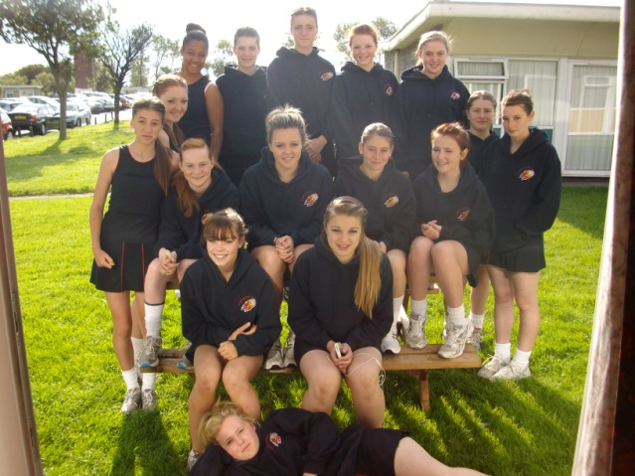
The Coaching Team | Both U14 Squads

Pontins – 22-24 June 2012 – Under 11s – Under 13s
This is our annual end of season tournament which takes place over a weekend in Somerset! As with the rest of the country it rained continuously from about 3pm on Saturday until the early hours in the morning to the extent that we thought that the Sunday part of the tournament would be cancelled! Thanks to the organisers, who were out at about 5.30am on Sunday, clearing the water off the courts to make them playable! And then sunshine!
Due to other commitments not everyone eligible to play was available which meant that we only took two squads and not our usual six (two per age group). We had one U11 and one U12 squad.
Both teams played really well on the Saturday despite being in very tough groups and qualified for the Plate competition to be played on Sunday.
Sunday arrived and all our teams were up early and, after Mary went and checked the conditions of the courts and got confirmation that the competition was going ahead, were raring to go! Both squads played really well and the U11s qualified for the quarter finals with the U12s narrowly missing out.
Well done girls you all played excellently and are a real credit to the club!
The Coaching Team
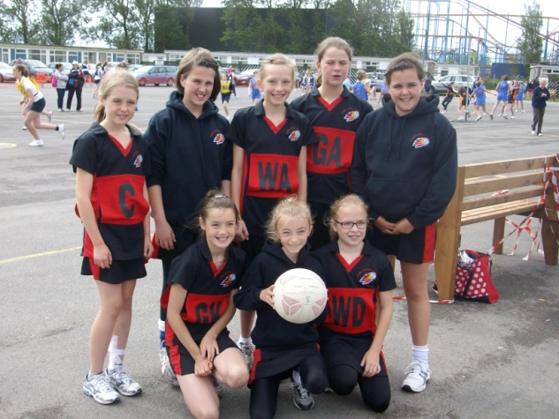 | 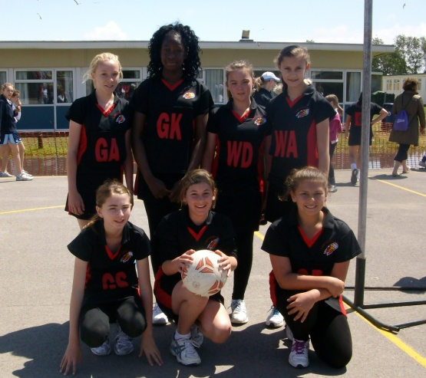
U11 Squad | U12 Squad

